Project Report
On
Distributed File System with fault tolerance

A Project Report Submitted in Partial Fulfilment of the Requirements for the Course
Operating System

Submitted By:
- Aditya Kumar -12518307
- Ayush Kumar - 12518548

Under the Guidance of
Mr. Sachin Kr Chawla Sir


Lovely Professional University, Phagwara, Punjab

Acknowledgement

We, the undersigned students of Lovely Professional University, are grateful to our project guide and the Department of Computer Science and Engineering for their continuous support and encouragement during the completion of our project entitled “Distributed File System with fault tolerance” We would also like to express our sincere gratitude to all faculty members for providing us with valuable insights into operating system concepts. This project has given us an opportunity to apply theoretical knowledge to a real-world simulation problem.
Group Members:
1. Aditya Kumar
2. Ayush Kumar

Self-Declaration Certificate

I hereby certify that the project entitled “Distributed File System with fault tolerance” submitted to Lovely Professional University is an original work carried out by me/us as part of the Operating System course requirements.
This project has not been submitted to any other university or institution for the award of any degree or diploma.
The project work has been completed under the guidance and supervision of the faculty members of the Department of Computer Science and Engineering.
I/we further declare that all the data, algorithms, and results presented in this report are genuine and derived from my/our independent efforts, and due acknowledgment has been made wherever external sources were used.

Submitted by:
- Aditya Kumar (12518307)
- Ayush Kumar (12518548)
Course: Operating System
Department: Computer Science and Engineering
University: Lovely Professional University
Date: __________________________
Signature(s): ____________________
Table Of Contents
- Project Overview
- Module-Wise Breakdown
- Functionalities
- Technology Used
  - Programming Languages
  - Libraries and Tools
  - Other Tools

- Flow Diagram
- Revision Tracking on GitHub
- Git Hub Link
- Git hub repository
- Conclusion and Future Scope
- References
- How Google Drive System Works (Compared with my DFS)

Project Overview

Distributed File System with fault tolerance
It designed to show how files can be stored safely across multiple nodes.
The main idea is that when a user uploads a file, it is not kept on just one node. Instead, the file is stored on multiple nodes by creating replicas.
This ensures that even if one or more nodes fail, the file can still be accessed from another active node.

The project simulates real-life cloud storage systems such as Google Drive, Dropbox, Mega, and iCloud.
These platforms also use the same concept of keeping multiple copies of your files on different servers so that your data is never lost.

To demonstrate this behaviour, the project includes features like:

Fail Node – simulates a node crash.
Recover Node – brings a failed node back online.
Repair Faults – re-creates replicas if some were lost due to node
Failure.

When a file is uploaded, it is stored in Node 1 and replicated to other nodes (Node 2, 3, and 4).
If Node 1 fails, the system can still download the file from another node.
This shows how a distributed system keeps files safe even during failures.

The main objective of this project is to show:

- How data is protected using replication
- How node failures can be handled
- How data can still be recovered after faults
- How distributed systems ensure high availability and reliability

Overall, this project provides a simple and clear demonstration of how large cloud systems protect user data from loss by using distributed storage and fault tolerance.

Module-Wise Breakdown

My Distributed File System (DFS) project is divided into several important modules.
Each module plays a role in storing, replicating, and recovering files inside the distributed system.
Breakdown:
1. Node Module
This module represents a single storage unit in the distributed system.
Responsibilities:
- Store files
- Check if a file exists
- Return file content
- Stay active or go down (fail)

How it works (from code):
Each node has a name, status (active or down), and a file map.
- If the node is active → it can store and return files.
- If the node is down → it cannot store or send any file.
This simulates real cloud storage servers.

2. Distributed File System (DFS) Module (class on my code)
This is the core module and handles all operations in the system.
Key parts inside DFS:
- List of all nodes
- Replication factor
- Upload logic
- Download logic
- Fault repair logic
- Node failure and recovery
- File distribution check
It is a part where I wrote code logics of my projects.

3. Upload File Module
This module handles the logic for storing a new file.
What it does:
- Takes filename + content from user.
- Stores the file in the first active node.
- Then creates copies in other nodes until the replication factor is met.
(Example: replication = 2 → store in Node 1 and Node 2)

When nodes are down:
- Upload still works, but if not, enough nodes are active, it shows a warning.

4. Download File Module
This module retrieves files from the system.
How it works:
- It searches for the file in all active nodes.
- If any active node has the file → it downloads successfully.
- If all replicas are lost or all nodes storing the file are down → download fails.
This shows real-world fault tolerance behaviour.

5. Fail Node Module
This module simulates a server crash.
What it does:
- Changes a node’s status from active → down.
- A down node cannot store or send files.
- Used to test fault tolerance.

This is similar to a cloud server going offline.

6. Recover Node Module
This module brings a node back online.
What it does:
- Changes node status from down → active.
- The node becomes ready to store files again.
- Needed after a simulated failure.
This is basically recovering the offline Node
7. Repair Faults Module
This is one of the most important modules—fault tolerance.
What it does:
- Checks how many replicas exist for each file on active nodes.
- If the number is less than the replication factor → missing replicas are recreated.
- Repairs data loss caused by node failures.
Example:
If file must have 2 copies but only 1 copy is left → repair will create the missing copy.

8. List Files Module
Shows how files are distributed across nodes.
Output shows:
- Node name
- Status (Active / Down)
- Files stored in each node
This helps visualize the internal working of DFS.

9. User Interface (CLI Menu) Module
This module provides the options to the user.
Menu options include:
- Upload File
- Download File
- Fail Node
- Recover Node
- Repair Faults
- List Files
- Exit
This allows the entire DFS system to be controlled easily.

Functionalities
1. File Upload
This functionality allows the user to upload a file into the system.
How it works:
- The file is first stored in an active node.
- Then it is replicated (copied) into other nodes based on the replication factor.
- If some nodes are down, it stores the file only in active nodes and shows a warning.
- This ensures that files are not lost and always have multiple copies.

2. File Download
This functionality helps users to retrieve a file from the system.
How it works:
- The system checks all active nodes.
- If any active node has the file, it returns the file content.
- If all nodes that had the file are down, the download fails.
- This shows how distributed systems recover files even during failures.

3. Node Failure Simulation
This function simulates a server or storage crash.
What it does:
- Makes a selected node “inactive” or “down.”
- A down node cannot store or serve files.
- It is used to test how the system behaves during failures.
- This mimics real-world issues like server crashes and disk failures.

4. Node Recovery
This functionality restores a failed node back to normal operation.
What it does:
- Makes a down node active again.
- After recovery, it can store and send files.
- This helps simulate how cloud systems bring failed servers back online.

5. Fault Repair / Replica Repair
One of the most important features of your project.
How it works:
- The system checks how many copies of each file exist in active nodes.
- If some copies are missing due to node failure, it creates new replicas.
- This restores the required number of copies.
- This represents fault tolerance, which means the system can repair itself.

6. File Distribution Display
This functionality displays:
- Which files are stored in which node
- Whether nodes are active or down
- How many replicas exist
- It helps users understand file distribution visually.

7. Replication Management
Your DFS ensures that files are always stored on multiple nodes.
Purpose:
- Prevent data loss
- Increase availability
- Balance storage load
- This makes the system more reliable during node failures.

8. User-Friendly CLI Menu
Your program provides an easy-to-use command-line menu.
It includes:
- Upload File
- Download File
- Fail Node
- Recover Node
- Repair Faults
- List Files
- Exit
This allows users to control the entire DFS easily.

Technology Used
Programming Languages
C++
C++ is used to build the main logic of the DFS system.
- Classes & Objects for Node and DFS design
- Vector for storing node objects
- Map for storing files inside each node
- Functions for upload, download, fail, recover, and repair operations
- C++ handles the core working and backend logic of replication and fault tolerance.

Java Script
JavaScript is used when converting the C++ logic into a web simulation.
- Button actions (Upload, Fail Node, Repair, etc.)
- Updating node status on screen
- Storing file data in JS objects
- Simulating node failure and recovery visually

HTML
HTML is used to create the structure of the user interface where:
- Nodes are displayed
- Buttons are provided
- File inputs appear
- This forms the visual layout of the simulation.
CSS
CSS is used to style the webpage and to visually show:
- Active nodes
- Failed nodes
- File storage display
- This makes the simulation clear and easy to understand.

Libraries and Tools
STL (Standard Template Library) – C++
- vector for managing node lists
- map for storing file–content pairs
- string for file content
DOM Manipulation (JavaScript)
- Node status (Active/Down)
- File display
- Replication counts
- directly in the browser.

Other Tools
GitHub
- Version control
- Storing code online
- Tracking changes (commits)
- Improving the project over time
- Sharing with others

VS Code
- C++ backend logic
- HTML/CSS/JS frontend simulation
- VS Code helps you manage all files in one place.

Flow Diagram
Below is the step-by-step flow of how your Distributed File System works internally.

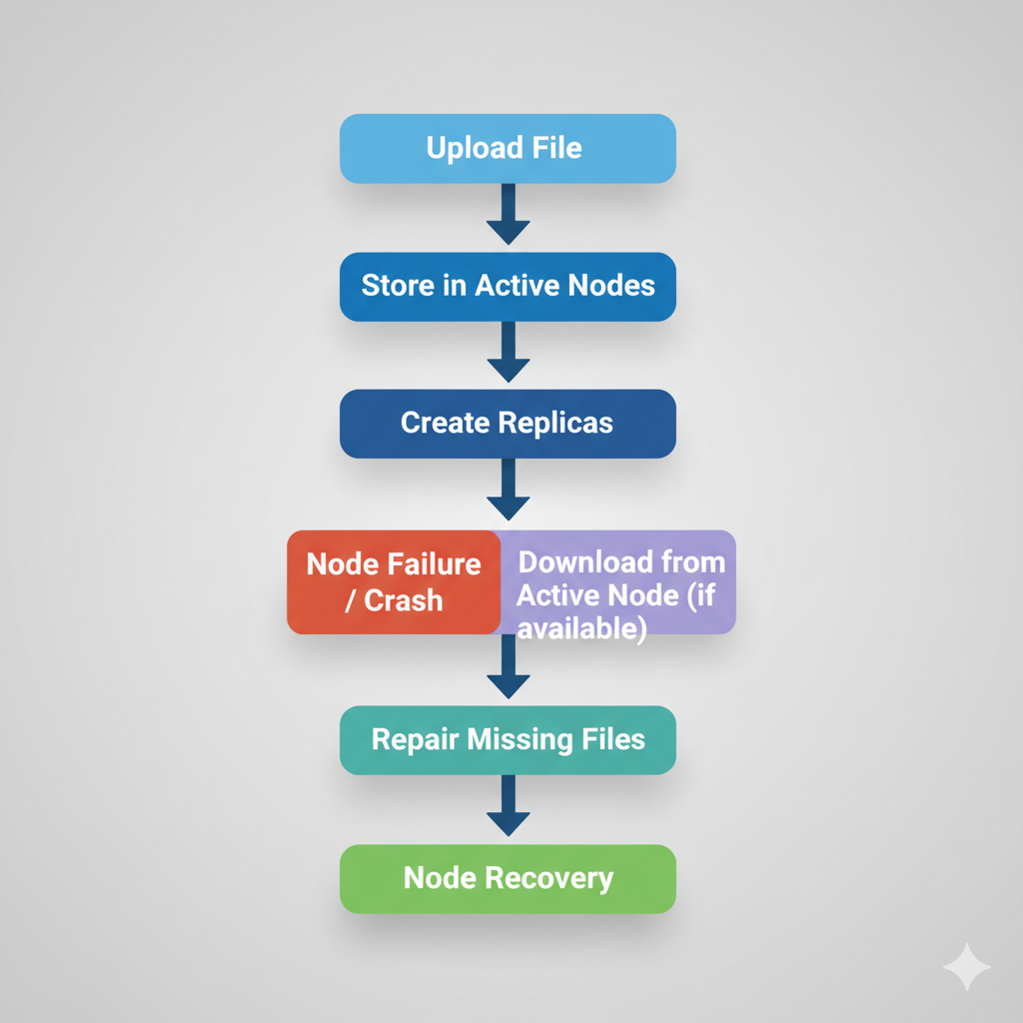
Revision Tracking on GitHub

• Repository Name: Distributed-file-system
• GitHub Link: https://github.com/adityak71/Distributed-file-system

Conclusion and Future Scope
Conclusion
This project successfully demonstrates how a Distributed File System (DFS) works with fault tolerance. By storing files across multiple nodes and creating replicas, the system ensures that data remains safe even if one or more nodes fail.
The simulation clearly shows how important features like file upload, file download, node failure, node recovery, and fault repair work together to protect user data.

The project also reflects how real cloud storage services such as Google Drive, Dropbox, Mega, and iCloud store multiple copies of user data to avoid loss during server crashes or technical failures. Through this project, the core concepts of replication, fault tolerance, and distributed storage become easy to understand.
Overall, the project achieves its main objective:
- Safely storing files
- Replicating data across nodes
- Recovering from node failures
- Maintaining data availability at all times

Future Scope
There are many ways this project can be improved or expanded in the future:
1. Add File Encryption
To make the system more secure and protect sensitive data.
2. Add User Authentication
Allow users to log in and manage their own files individually.
3. Improve the Frontend UI
Create a cleaner and more modern interface for visualizing nodes and file movement.
4. Add Real Databases
Store file metadata in databases like Firebase, MongoDB, or MySQL for better structure.
5. Add Load Balancing
Automatically select the best node to store new files based on available space or performance.
6. Add Cloud or Network Support
Make the system work over multiple real computers on a local network or cloud.
7. Add Version Control for Files
Keep different versions of the same file, like Google Drive.
8. Add Auto-Recovery
Automatically detect node failure without user input and start repairing replicas automatically.
9. Increase Replication Intelligence
Use algorithms to choose the best nodes for storing replicas based on node health.
10. Add Monitoring Dashboard
Show node health, stored files, and replica count in real time.
References
- Distributed Systems Concepts – Replication, Fault Tolerance (Educational Reference)
- Cloud Storage Architecture – Google Drive, Dropbox, iCloud (General Understanding)
- C++ Standard Template Library (STL) – Official Documentation
- GitHub Documentation – Version Control & Repository Tracking
- Your own project code and simulation logic
- Classroom notes and instructor guidance
- Used AI for Doubt And challenging Solving

How Google Drive System Works (Compared with my DFS)

Google Drive works on a large-scale Distributed File System very similar to the concept used in my project.
Instead of storing files on a single computer, Google spreads your data across many servers and data centres around the world.
This ensures that your files are always safe, always available, and never lost — even if some servers fail.
1. File is Split and Stored Across Multiple Servers
When you upload a file to Google Drive:
- The file is divided into smaller chunks.
- These chunks are stored across many different servers (nodes).
- Google does not keep your full file in one place — it distributes it.
This is the same concept I used:
File stored in Node 1 → Replica copied to Node 2, 3, 4.
2. Replication for Safety (Fault Tolerance)
Google stores multiple copies (replicas) of your file.
For example:
- One copy in Data Centre A
- One copy in Data Centre B
- One copy in Data Centre C

Even if one full data centre catches fire or loses power, your file is still safe.
This is exactly what my DFS project shows:
If Node 1 fails, file can still be downloaded from Node 2, Node 3, etc.

3. Automatic Healing (Repairing Lost Data)
If Google detects that a server is damaged or goes offline:
It immediately creates new copies from the existing replicas.
This process is called self-healing.

My project has the same feature:
The Repair Faults module checks missing copies and recreates them.

4. Load Balancing
Google has millions of users uploading at the same time.
To handle this, Google uses load balancers to assign the file to:
- the fastest server
- the nearest server
- a server with free space
This prevents any one server from getting overloaded.
In my project:
- I store files in the first available active node.
- This is a simple version of load balancing.

5. Node Failure Detection
Google continuously monitors all its servers.
If a server becomes slow, overheated, or unresponsive:
Google marks it as Down
Immediately starts moving data away from that node
In my DFS:
“Fail Node” button simulates exactly this behaviour.

6. Worldwide Data Centres
Google Drive does not depend on one location.
It has data centres in:
- USA
- Europe
- Asia
- Australia
- Many other regions
Your file may exist in several of these locations (encrypted).
This provides:
- High availability
- High speed
- Global accessibility

My DFS is a mini version:
- Node 1 = one server
- Node 2 = second server
- Node 3 = third server
- Node 4 = fourth server

7. Metadata Management
Google Drive stores information like:
- File name
- Size
- File type
- Location of chunks
- Replication count
This metadata is stored separately in a master server.
Similarly, My DFS does:
- Store file name
- Store file content in nodes
- Manage replicas
- Check active nodes

8. Encryption and Security
Google Drive encrypts your files in two ways:
- During upload (in transit)
- After storage (at rest)
Even Google employees cannot directly read your files.
This is one feature I could add in project’s Future Scope.
Summary
Google Drive works using the same principles as My project:
